**Areas Related to Circles**

1. A **circle** is a set of points in a plane that are at an equal distance from a fixed point. The fixed point is called the centre of circle and equal distance is called the radius of the circle.
2. A line segment joining the centre of the circle to a point on the circle is called its **radius**.
3. A line segment joining any two points of a circle is called a **chord**. A chord passing through the centre
4. of circle is called its **diameter**.
5. The distance around the boundary of the circle is called **the perimeter or the circumference** of the circle.
6. Circumference (perimeter) of a circle = *d* or 2*r*, where d is he diameter, *r* is the radius of the circle and **  22 .

7

1. Perimeter of a semi circle or protractor = *r + 2r*
2. Perimeter of a quadrant = 1 Circumference  2*r* =

4

* r*  2*r* 2

1. Distance moved by a wheel in 1 revolution = Circumference of the wheel.

Number of revolutions in one minute = Distance moved in 1 minute

Circumference

1. The region enclosed inside a circle is called its **area**.
2. Area of a circle = *r*2
3. Area of a semi circle =

1 * r* 2

2

1. Area of a quadrant = 1 Area of circle

4

 1 * r* 2

4

1. Circles having the same centre but different radii are called **concentric circles**.

Area enclosed by two concentric circles = * R*2  * r* 2  ** *R*2  *r* 2   ** *R*  *r* *R*  *r* 

Where, R and r are radii of two concentric circles

1. The part of the circumference between the two end points of the chord is called an **arc**. In the figure, arc  is shown.

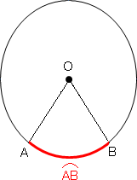

1. A diameter of circle divides a circle into two equal arcs, each known as a **semi-circle**.
2. An arc of a circle whose length is less than that of a semicircle of the same circle is called a **minor arc**.
3. An arc of a circle whose length is greater than that of a semicircle of the same circle is called a **major arc**.
4. Length of an arc =

* r*

180

1. The region bounded by an arc of a circle and two radii at its end points is called a **sector**.

If the central angle of a sector is more than180 , then the sector is called a **major sector** and if the central angle is less than 180 , then the sector is called a **minor sector**.

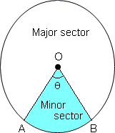

1. Perimeter of sector of angle  =

* r*  2*r* 180

1. Area of a sector of angle  =

* r* 2**

360

1. Area of major sector = *r2* – Area of minor sector
2. A chord divides the interior of a circle into two parts, each called a segment.

The segment which is smaller than the portion of semi-circle is called the **minor segment** and the segment which is larger than the portion of semi-circle is called the **major segment**. In the circle shown, the yellow portion is the minor segment while the non-shaded portion is the major segment.

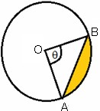

1. Perimeter of segment of angle  

r  AB 180

1. Area of minor segment = Area of sector - Area of  ABC

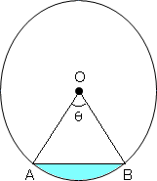

1. Area of minor segment can also be written as:

Area of segment *ACB* =  ** ** 

 *o*

360

** **  2

sin 2 cos 2  *r*

 ☑

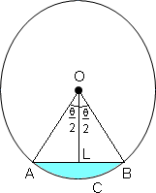

1. Area of major segment = Area of the circle – Area of minor segment